We learned optimizer such as SGD, Adagrad, RMSProp, Adadelta, and Adam. Research the other two state-of-the-art optimizers and explain their feature.
Reply:
- Momentum:
The Momentum algorithm uses the concept of momentum in physics. It simulates the inertia of an object when it is moving, that is, it retains the previously updated direction to a certain extent when updating, and uses the gradient of the current batch to fine-tune the final update direction. In this way, the stability can be increased to a certain extent, so that the learning is faster, and there is a certain ability to get rid of the local optimum:
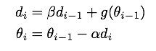
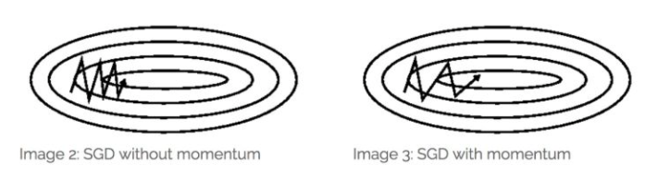
* Momentum is an improvement from SGD.
- Nesterov Accelerated Gradient (NAG):
NAG is an improvement from Momentum.
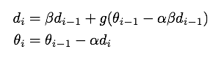
NAG can get a faster converges than Momentum.
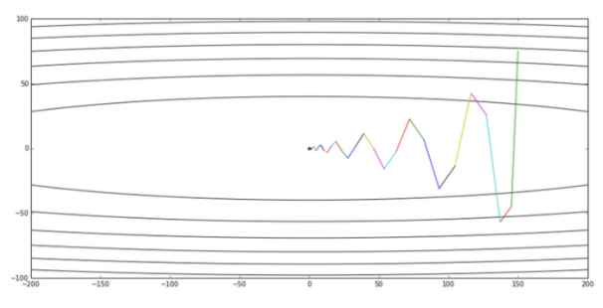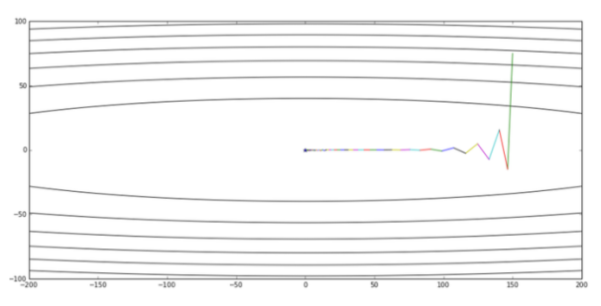
Figure 1. Momentum Figure 2. NAG

